SLEEP - Making Changes - or should you even try?

|  |
| --- |
|  |

**Firstly, take a moment to read some facts about sleep:**

|  |  |
| --- | --- |
| **C:\Users\BirdJ006\AppData\Local\Microsoft\Windows\INetCache\IE\QPH0532A\sleep[1].jpg** | **Sleep is an active process where we process the day and restore energy levels.** |

* Adults need between 7-9 hours of sleep but this varies from person to person.
* There are different sleep problems. For example you might
  + - Have trouble falling asleep but then sleep through the night
    - Wake often throughout the night or wake up too early
    - Not be aware of disrupted sleep but not waking up feeling refreshed
* To fall asleep our nervous system has to calm down. When you are in pain your nervous system is a lot more activated and it can take longer to drop off to sleep or impact how deep your sleep will be.
* A healthy sleep pattern (“sleep cycles”) moves through different stages. You don’t actually drop off to sleep and stay in a deep sleep for the rest of the night. It is normal to wake up several times throughout the night when we move from one “sleep cycle” to the next.
* Pain affects sleep but so do a lot of other factors as well. Light, noise, room temperature, worries and thoughts all impact your quality of sleep. The good news is, that these might be easier to control than pain itself and therefore can be the key to an improved night sleep!

|  |  |
| --- | --- |
|  | **Pain can contribute to poor sleep but poor sleep can also increase how we will experience pain.**  **A good night’s sleep can actually help us manage pain!** |

How does normal sleep work?

* You can see in the graph how we move from being awake through lighter stages of sleep (Stage 1 and 2) to deeper stages of sleep (Stage 3 and 4) at the beginning of the night.

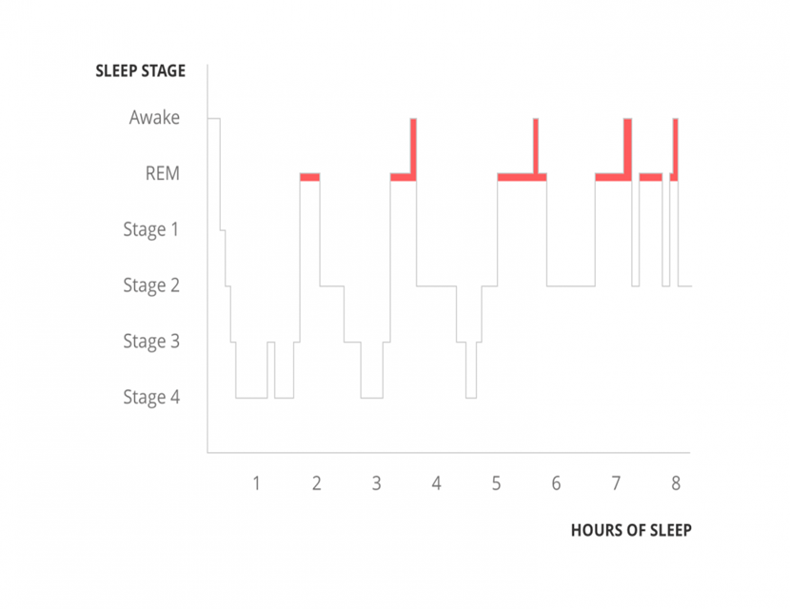

https://painhealth.csse.uwa.edu.au/pain-module/sleep-and-pain/

* We then move up to lighter stages of sleep again and into REM “rapid eye movement”) sleep which is where we dream.
* You can see that often people will wake from REM sleep for a short while. Most of the time we are not aware of this and will simply roll over and drop off again.

|  |  |
| --- | --- |
|  | **When you are experiencing pain you might notice the pain when you are more awake during the night. Your nervous system will be more activated and it will take longer for it to calm back down and for you to fall asleep again.** |

**There is some good discussion of it on this website.**

* <http://healthysleep.med.harvard.edu/healthy/science>

|  |  |
| --- | --- |
| C:\Users\BirdJ006\AppData\Local\Microsoft\Windows\INetCache\IE\IBGWX5XM\idea-3383766_960_720[1].jpg | **If you can manage to learn how to calm down and fall asleep more quickly at the beginning of the night, the same strategies will also help you to fall back asleep during the night.** |

What else can affect how well we sleep?

* Stress and anxiety
* Sleep environment ( e.g. uncomfortable bed, bedroom that’s too loud, noisy, warm or cold)
* Lifestyle factors (e.g. jet lag, shift work, drinking alcohol or caffeine before going to bed)
* Mental health conditions (e.g. depression)
* Physical health conditions (e.g. long-term pain, other sleep disorders, etc)
* Certain medicines (e.g. some antidepressants, epilepsy medicines and steroid medication)
* Genetics

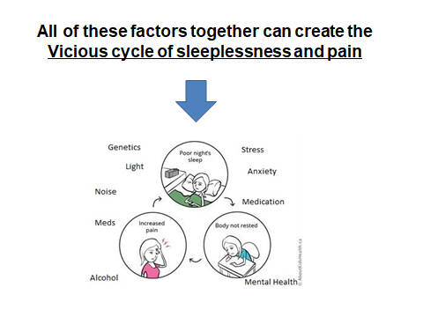

How can we begin to break out of this vicious cycle of sleeplessness and pain?

If you have never tried the approaches outlined below, you may like to have a go (remembering be gentle with yourself when your making changes and that you might feel more fatigue before the body’s natural sleep cycle re-surfaces).

**Below are some guidelines on doing so:**

To work with sleep problems:

* 1. TAKE NOTES. Start by using a journal or notebook to keep track of your bedtimes and wake up times. You can also make a note when you find something that might trigger poor sleep.
  2. GET INFORMED. For example, you can go through the topics discussed in this section. Or you can find information about sleep here:

<https://thesleepschool.org/>

[Sleep problems - Every Mind Matters - NHS (www.nhs.uk)](https://www.nhs.uk/every-mind-matters/mental-health-issues/sleep/)

* 1. MAKE A PLAN. How do you relate to the different factors which influence your sleep ? Think about how to make small changes which may help you to sleep.

Remember, often more than one factor is involved in sleep problems and you need to change more than one thing to feel the benefit.

Putting theory into practice: So far so well, … but where do I start?



Start by changing the easiest things first and work up to the more complex factors

*(e.g. start with setting a realistic bed time and work your way up to managing worrying and ruminating at night).*

Don’t try to change everything all at once – plan a timetable and work on one change at a time.

**REMEMBER: It will also take time to unlearn any unhelpful habits or associations you have acquired, so be patient and keep going with your plan so you can see changes.**

What can impact sleep

**Sleep routine**

Building a strong sleep routine can help getting better quality sleep.

* Stick to your bed times – going to bed and getting up at roughly the same time helps keep your body clock in time. This can also strengthen your immune system and reduce inflammatory chemicals in your body.
* Create a “winding down routine” – spend about 30 min each night doing the same things in the same order (e.g. taking a shower, brushing teeth, etc) finish with a calming activity, like reading a book or a short meditation.
* Take a power nap – this helps with:
  + Managing energy levels during the day
  + Managing stress levels and lessen pain
  + Bolstering your immune system
  + **BUT** keep it **under 30 min and not later than 3pm** for it to be most effective!
* Be mindful – practicing mindfulness during the day and at night can help you manage unwanted thoughts and feelings.
  + Be kind to yourself – remember that sleeplessness is a natural side effect of chronic pain! Fighting against it might make it worse. Try to be accepting that you might have some level of sleep difficulties will reduce the distress you feel around your sleep.

**Sleep hygiene**

“Sleep hygiene” means managing all the things you do during the day that can affect your sleep. It also means your sleep environment (e.g. having a calm and comfortable bedroom). Here are the most important examples:

* Diet – follow a balanced nutritious diet during the day.
  + Avoid heavy, fatty or sugary foods before bed
  + Avoid caffeine, like in coffee, tea, energy drinks, chocolate etc 4 hours before bedtime
  + Try some milk before you go to bed as it is sleep promoting.
* Exercise – even a little bit of exercise helps with a better sleep
  + **BUT** leave at least 2 hours until your bedtime as it will increase your heart rate and body temperature making it harder to fall asleep.
* Pacing – practice pacing during the day to avoid “flare ups” in the evening!

**Sleep environment**

* ****Light – the sleep hormone Melatonin is produced when there is a big enough difference between “day light” and “evening darkness”. Here are some suggestions how you can achieve this:
  + - Increase exposure to natural daylight during the day (e.g. spend enough time outside)
    - Decrease exposure to light in the hours leading up to your bedtime (e.g. dim the lights, etc)
    - Avoid “screen time” in the hour before your bedtime (e.g. try reading a book, knitting, playing cards etc)
* Noise – try to create a calm and quiet sleep environment. Some things (e.g. traffic noise, loud neighbours, etc) might be out of your control. Try to manage those in the best way possible, for example by using ear plugs, using a “white noise machine”, changing bedrooms, etc
* Temperature – our core body temperature drops off when we are falling asleep.
  + Taking a warm shower in the evening might help as the initially warming effect is followed by a cooling of your core temperature just as if you are falling asleep.
  + Keep your bedroom temperature not too cold and not too warm.

Worrying and sleep

**Did you know…**

The biggest factor in sleep difficulties is often worrying about not sleeping!

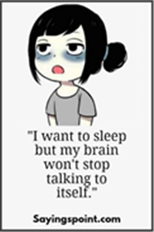Insomnia can become a struggle and the more you fight against it the stronger it seems to become. (‘What you resist, persists…’).

This increases the activity in your nervous system and makes it harder to wind down and drop off to sleep.

Here are some tips for how to manage difficult thoughts and feelings around bedtime:

* Remove the clock from your bedroom - watching the clock can increase anxious thoughts around sleeplessness.
* Expect some level of sleep difficulties to come with experiencing chronic pain. This is normal. Accepting this can help relieve some distress that otherwise comes with this.
* Racing thoughts – Anxiety and stress often lead to an overactive mind with thoughts that don’t want to switch off. Mindfulness practices letting go of thoughts. You cannot stop thoughts from popping into your mind but you can learn how to refocus your attention on the here and now, and let those thoughts pass.
* If you have had a busy day, you could try ‘putting the day to rest’ – taking some time in the early evening to run through the day in your mind, process what has happened, and make a note of anything which you need to do. This will help to prevent those thoughts or memories popping up in the middle of the night instead.
* Keep a worry diary. Write down the most difficult or pressing thoughts and promise yourself that you will deal with it in the morning.

There is nothing you can do at 11pm, or 3am, that can’t wait until the morning!

* Low mood and depression can lead to early morning waking. Getting treatment can help with sleep.

**REMEMBER to take it slow and be kind to yourself!**

Top Tips

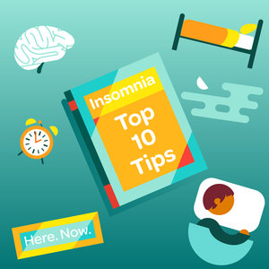One of the lead clinicians in a London sleep clinic, Dr Guy Meadows, talks about the limits of many sleep techniques. He notes that doing these can actually end up turning into a fight to ‘get to sleep right’ and making the natural cycle of sleep less likely!

You can find more information here:

<https://thesleepschool.org/>

**DON’T** create a strict set of procedures you MUST follow to be able and have a good quality sleep.

**TRY instead** to create a gentle set of rituals that work for you.

**TRY** to see such ‘sleep hygiene’ rituals as a gentle ‘wind down’ time, to limit the running around all evening then dropping into bed and wondering why our head is still buzzing.

**TRY** to keep a fairly balanced sleep/wake cycle, whilst, as best you can, dropping the struggle that can exist when sleep does not ‘happen’. This approach may help with getting regular good quality sleep.

**DON’T** battle with your unwanted thoughts and feelings around and about sleep. This can just make your head busier.

**TRY instead** to see thoughts less as facts but as what they actually are: just thoughts. Practicing mindfulness can help letting them go.

**DON’T** force relaxation in the evening – it is not relaxing to know you need to be relaxed.

**TRY instead** to practice pacing and mindfulness during the day so your stress levels don’t spike in the evening.

These are some ideas you can use **BUT most importantly,** notice how you relate to them. Using what works gently and persistently but without expecting that it will do more than *influence* our sleeping.

**Be kind to yourself, take care of yourself and with patience sleep will re-establish itself if we let it!**